Sudoers’ Phase 1 Source

Raysean Jones-Dent, Tonye Andre Martial, Matthew Mitchell,

Kristine Dudley, Woo Choi, Justin Kim

21 April 2019

CMSC 495 7982

Dr. Janell Robinson

University of Maryland University College

**Contents**

Version History 3

Original Milestones 4

Issues Encountered 5

Modifications 6

Working Program 7

# Version History

|  |  |  |
| --- | --- | --- |
| **Date** | **Version** | **Description** |
| 4/16/2019 | Version 1 | Document creation |
| 4/17/2019 | Version 2 | Added necessary information to content sections. |

# Original Milestones

Our team originally submitted key milestones with week 2 assignment Project Plan. Currently, our team is on schedule having completed all major milestones in accordance with the rubric. Week 5 goal of initial GUI coding has been met and tested by developing a FakeAtmService with a preloaded user. This has allowed us to check the functionality of the ATM and make design changes to the UI. Below is a snapshot of milestones through week 6.

|  |  |  |  |
| --- | --- | --- | --- |
| **Tasks** | **Start Date** | **End Date** | **Goal Met?** |
| **Develop Project Plan- Establish requirements, determine weekly leads & roles** | March 25, 2019 | March 31, 2019 | YES |
| **Develop User Guide & Test Plan, establish test cases** | April 1, 2019 | April 7, 2019 | YES |
| **Peer Review 1** | April 1, 2019 | April 7, 2019 | YES |
| **Project Design- Develop coding framework & UI design, UML class diagram, XML entities** | April 8, 2019 | April 14, 2019 | YES |
| **Peer Review 2** | April 15, 2019 | April 21, 2019 | TBD |
| **Phase 1 Source- Begin initial GUI coding & documentation** | April 15, 2019 | April 21, 2019 | YES |
| **Phase 2 Source- Complete GUI & begin coding backend (ATM transactions, language setting)** | April 22, 2019 | April 28, 2019 | TBD |

**Issues Encountered**

To date, Sudor’s have not had any specific problems or special circumstances. Our team is thriving, with all members actively participating and adding input during the weekly meeting(s). Every member has shown flexibility in schedules for impromptu meetings to discuss details of the project. Communication is the stronghold of our group and has allowed us to efficiently produce great work and meet deadlines.

There is currently one minor issue encountered for the code which is setting the language preferences for the GUI. This matter was resolved in our weekly meeting with one team member volunteering to conduct the initial research, coding, and testing of allowing our system to generate languages on the login screen only. Once that member has found the solution the rest of the team members will each take a .java/.fxml file to implement the language changes for each scene of the GUI. After testing all functions of the GUI using FakeAtmService.java file our team will begin implementing changes for the actual AtmService which will read and write to a .xml file.

# Modifications

Detailed below is a list of all previously submitted project documentation and a short summary of any changes made. The updated document files are being maintained on our github account allowing easy access and changes to be submitted by all members.

* Project Plan Submitted Week 2, Updated Week 5
  + Requirement Specifications:
    - Removed function and wording for creating a new user account.
    - Removed function and wording for allowing ATM user to login with phone number, PIN, account number, and last 4 digits of their SSN. User will now only login with username and PIN.
    - User’s Guide Submitted Week 3, updated Week 3 & 5
      * Updated screen shots for entire project to reflect actual GUI output.
* Test Plan Submitted Week 3, updated Week 5
  + Added a test case for viewing account history transactions.
  + Added individual test cases for each language.

# Working Program

Below are screenshots to show working functionality of the GUI. As stated earlier the goal for this week was to develop the GUI and test each function. Login username is “sc” and assigned PIN is “12345”. Account balances have been pre-loaded with $1.11 in checking and $2.22 in savings.

**LOGIN SCREEN**

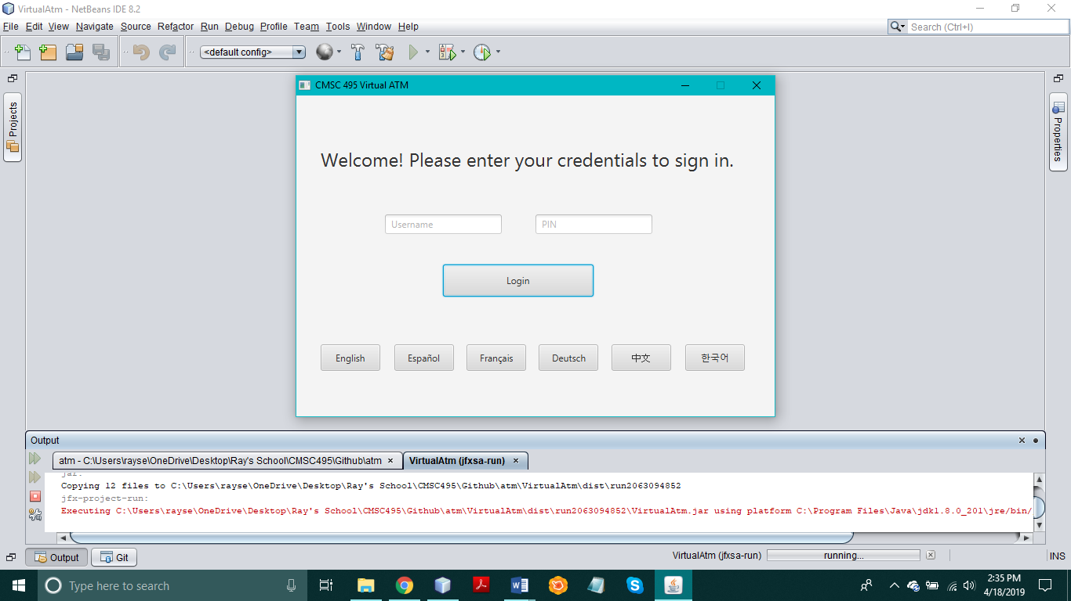

**NO PIN ENTERED**

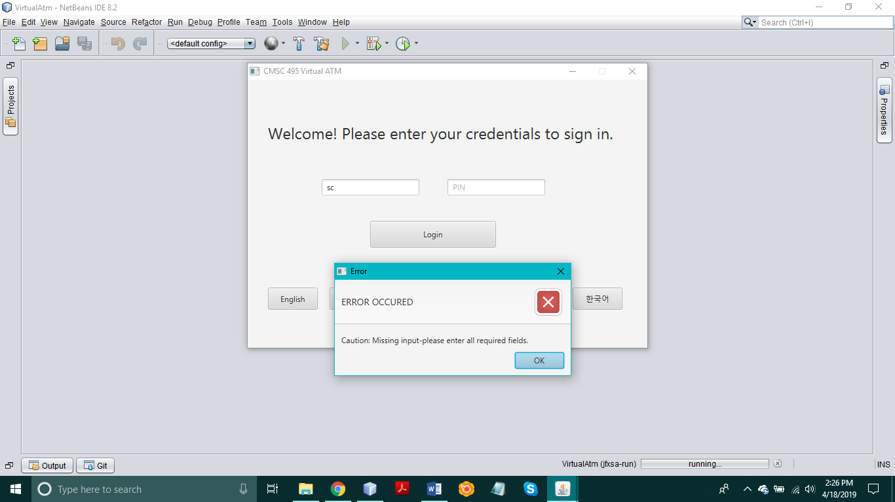

**NO USERNAME ENTERED**

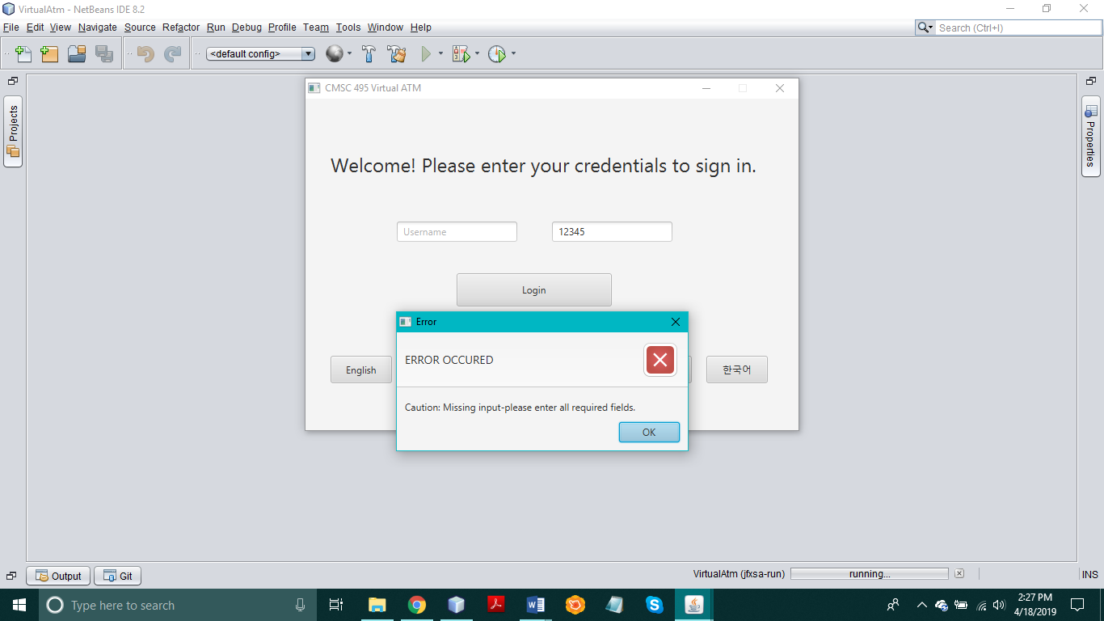

**INCORRECT USERNAME/PIN**

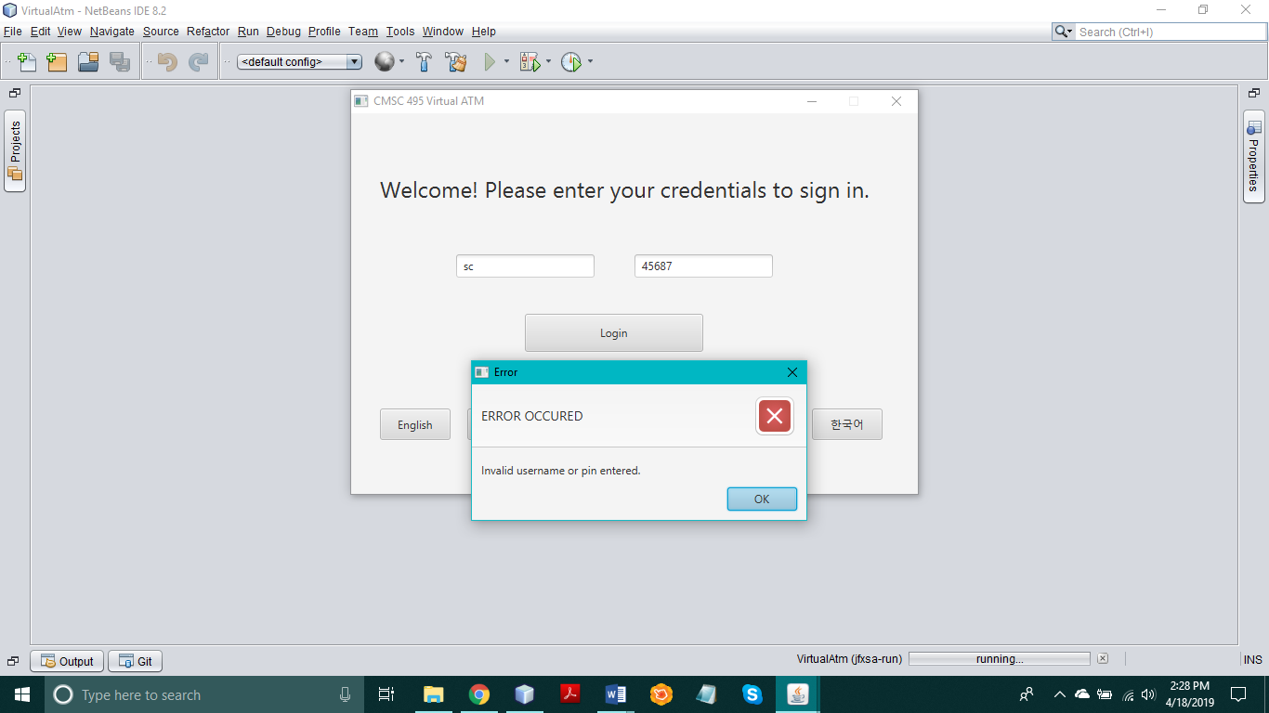

**MAIN PAGE(HOME PAGE)**

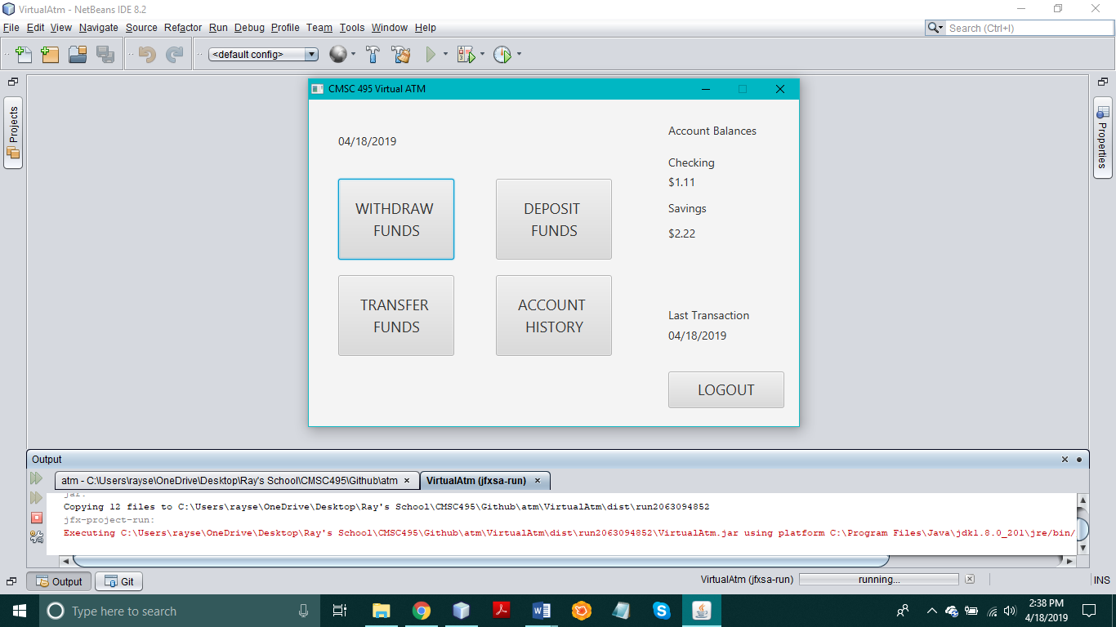

**DEPOSIT INTO CHECKING**

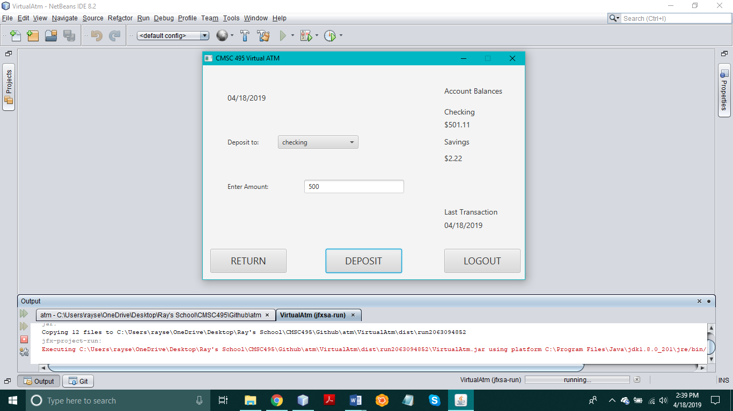

**DEPOSIT INTO SAVINGS**

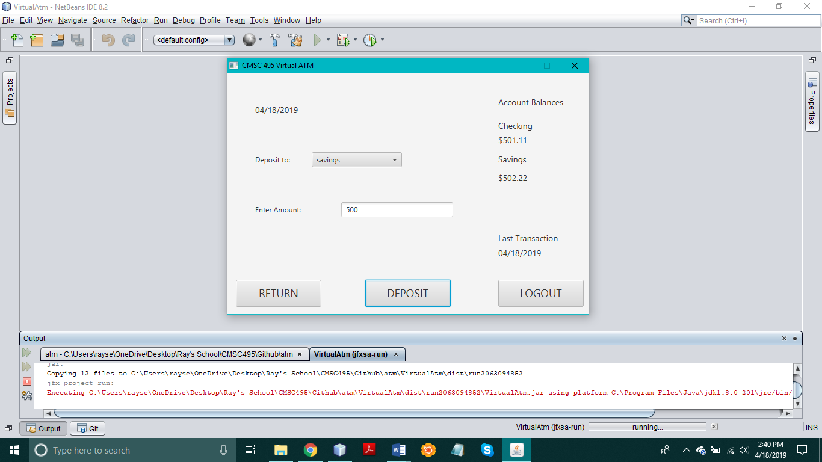

**TRANSFER FROM CHECKING – SAVINGS**

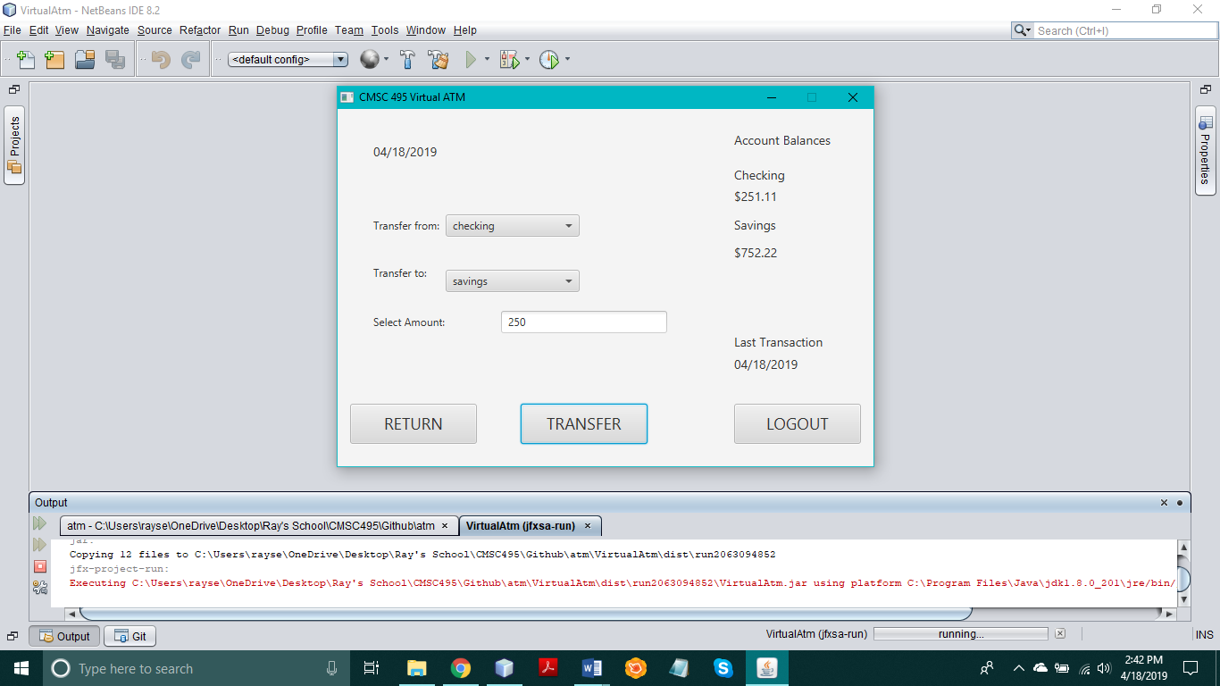

**TRANSFER FROM SAVINGS – CHECKING**

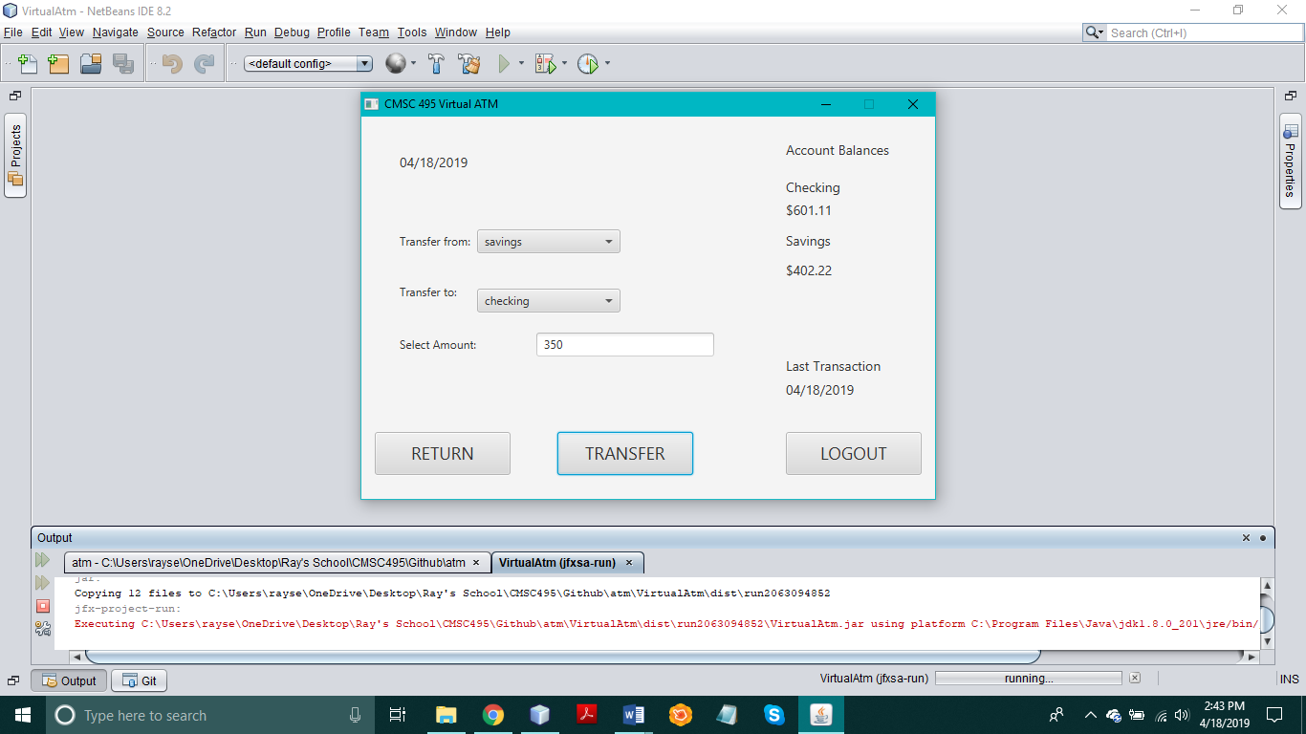

**WITHDRAWAL FROM CHECKING**

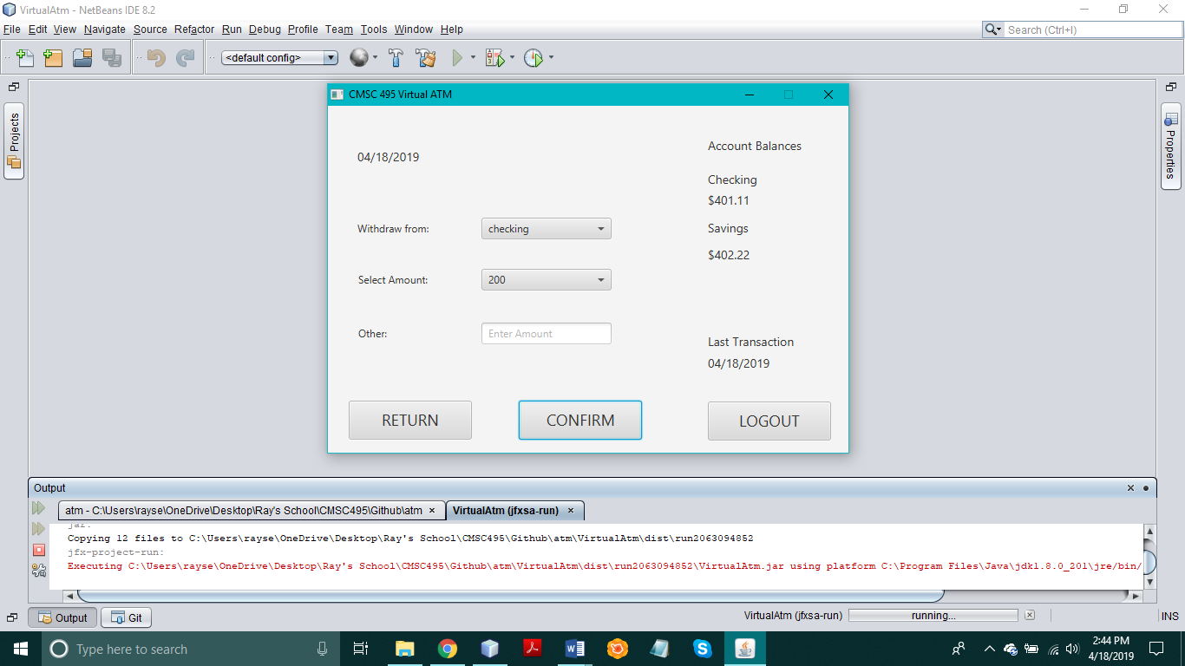

**WITHDRAWAL FROM CHECKING(OTHER)**

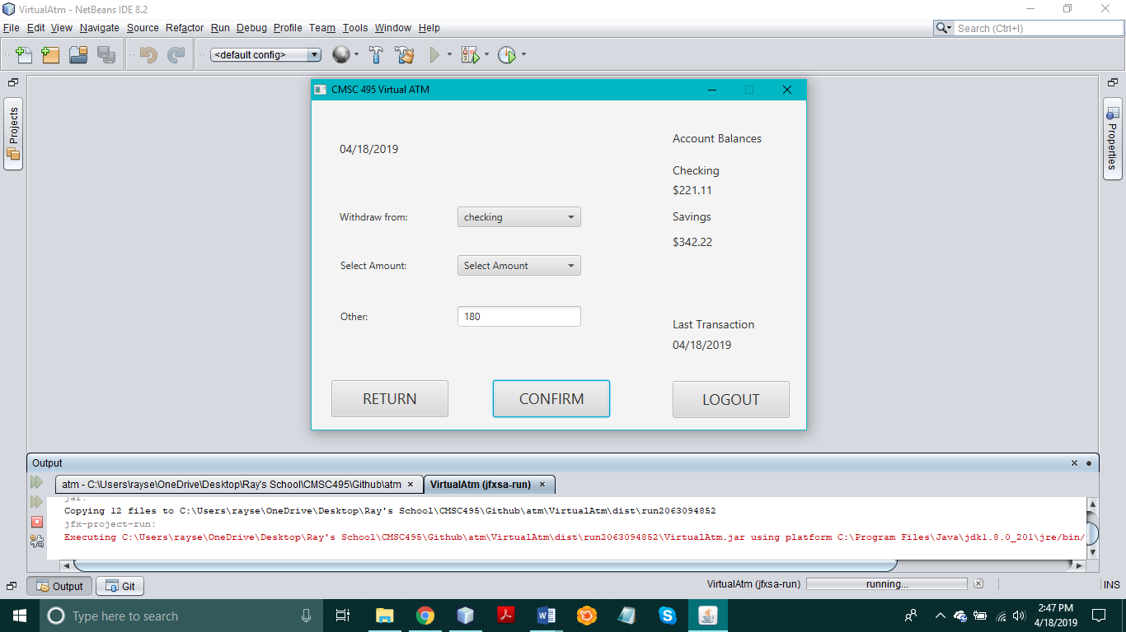

**WITHDRAWAL FROM SAVINGS**

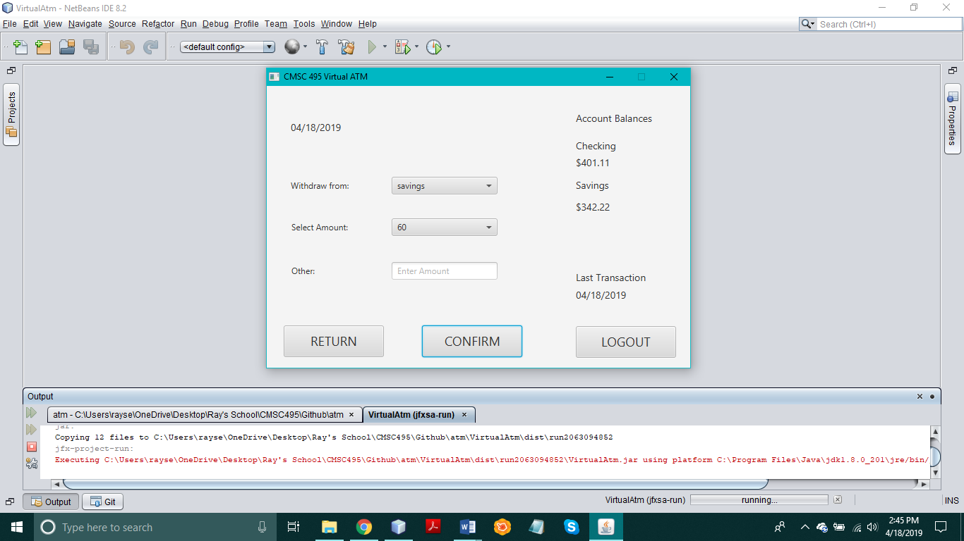

**WITHDRAWAL FROM SAVINGS (OTHER)**

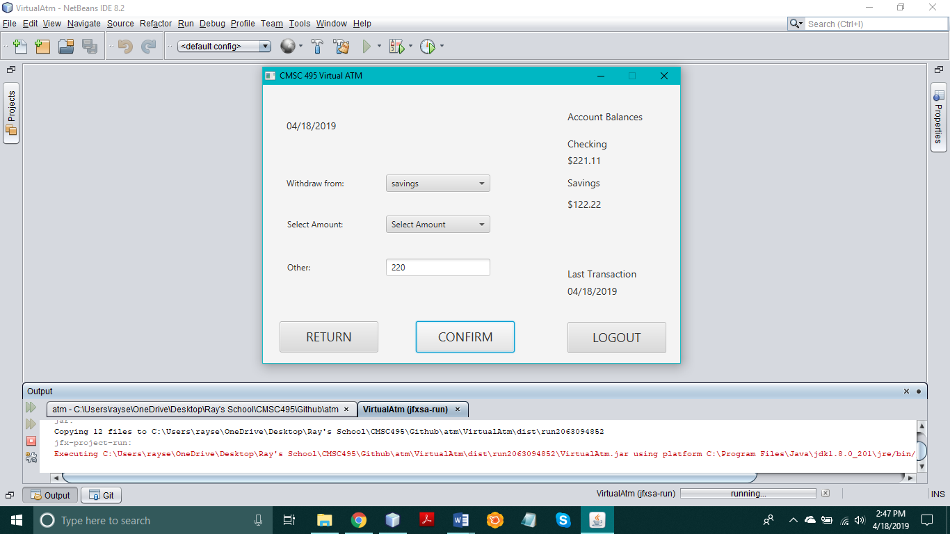

**ACCOUNT HISTORY(1st set of transactions)**

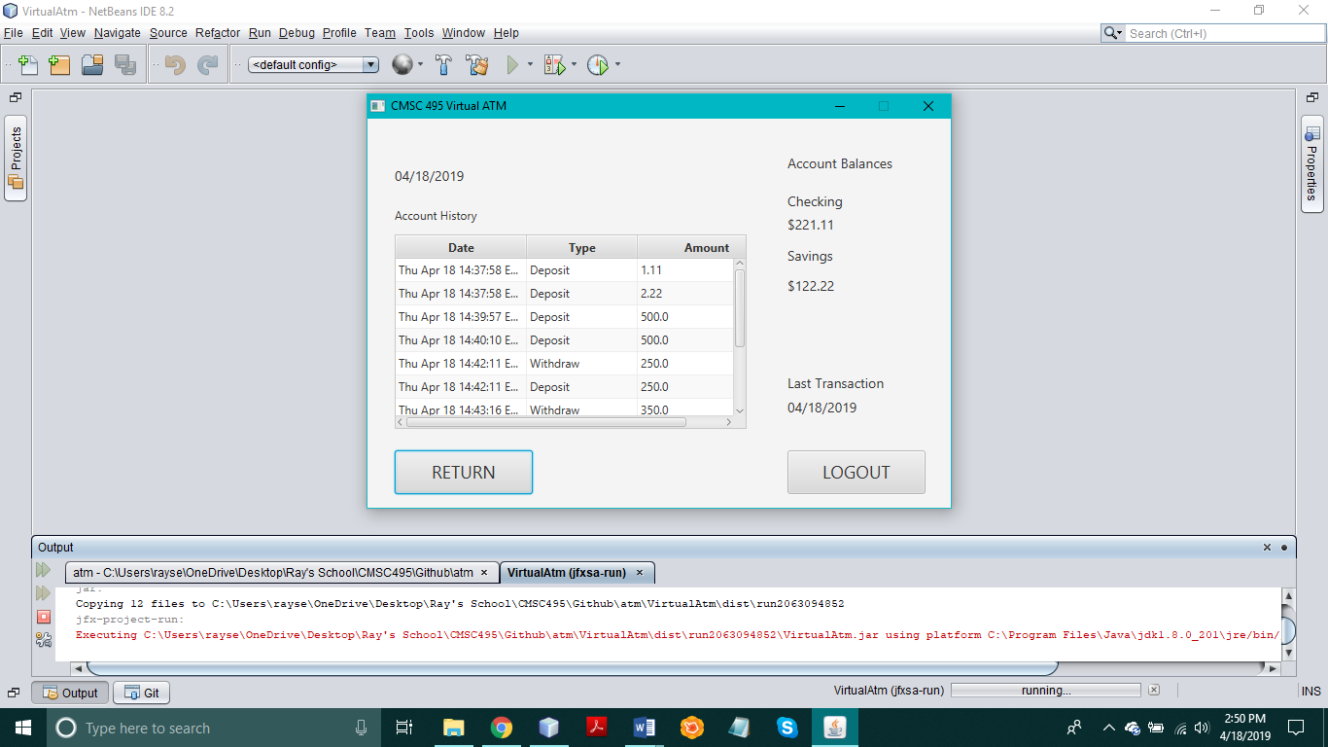

**ACCOUNT HISTORY(2nd set of transactions)**

